For sale: baby shoes, never worn.
Ernest Hemingway
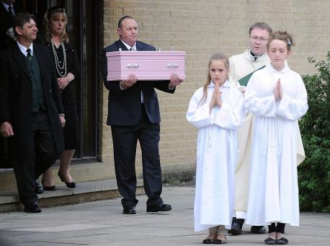
For sale: Baby shoes, never worn is the entirety of what has been described as a six-word novel, making it an extreme example of what is called flash fiction or sudden fiction. The power of those 6 words can create an entire novel.
Your task is to create your own six-word story or memoir with a corresponding image and summary.
- Decide on a subject and tone.
- Choose your words carefully for your intended tone; you only get six. Remember the power of precision.
- Look at the order of your words; can you reorder them for a positive effect?
- Add punctuation that lends itself to your tone.
- These are due the moment you walk in to the room on Thursday. I will be asking you to submit on turnitin as well-make it your own work.
- Looking for something extra to warm my heart? Write a six-word sequel.

